

**Lab Manual**

**Computer Engineering – Artificial Intelligence**

**B. Tech. Year – II, 5th Semester, Academic Year (2023)**

**Subject Code: 01AI0501**

*Subject Name: Advance Java programming*

*Name: Basid Al Siddik Shammo*

*Enrollment Number: 92100151052*

**PROGRAM-01:** The program reads its own source file, which must be in the current directory.

**CODE:**

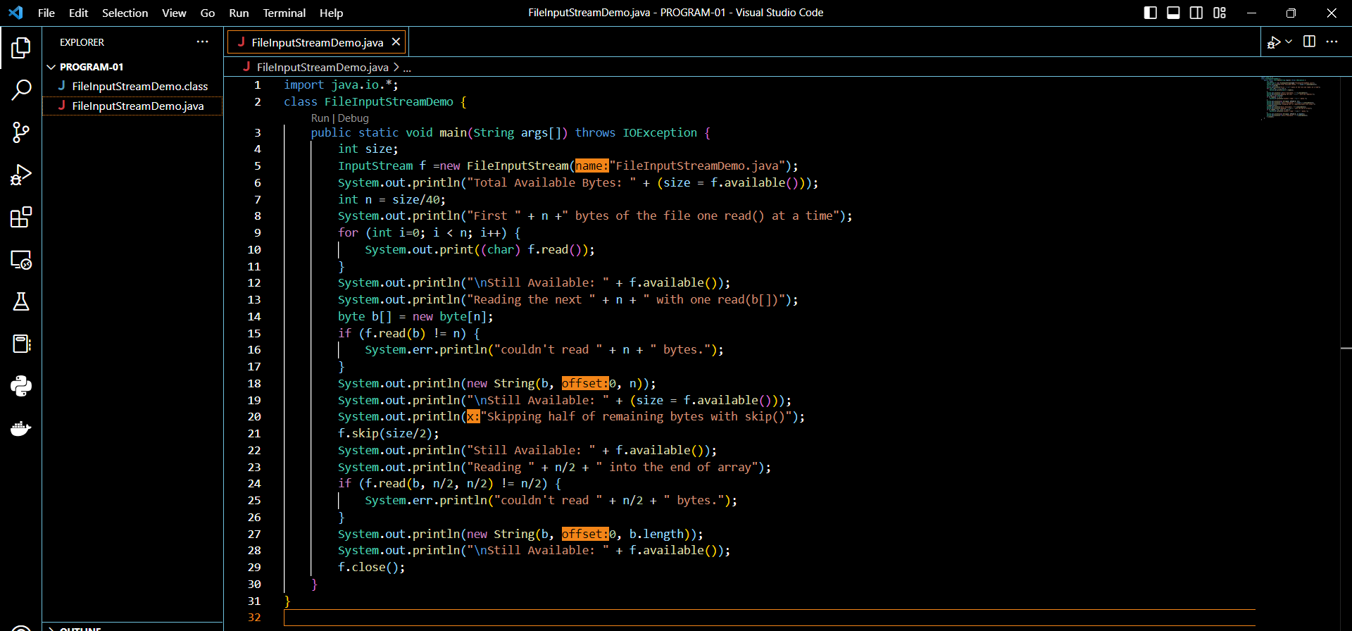

**Result-**

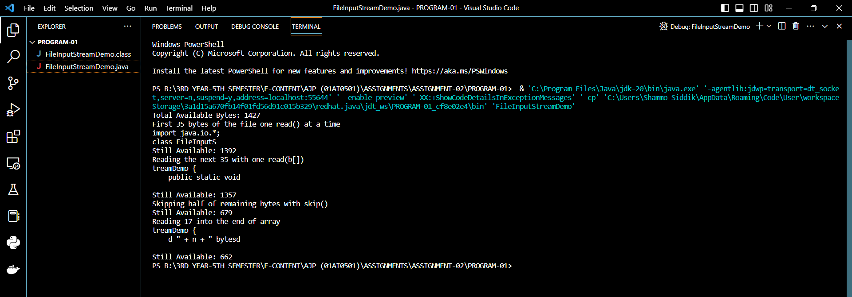

**PROGRAM-02:** Demonstrate FileOutputStream.

**CODE:**

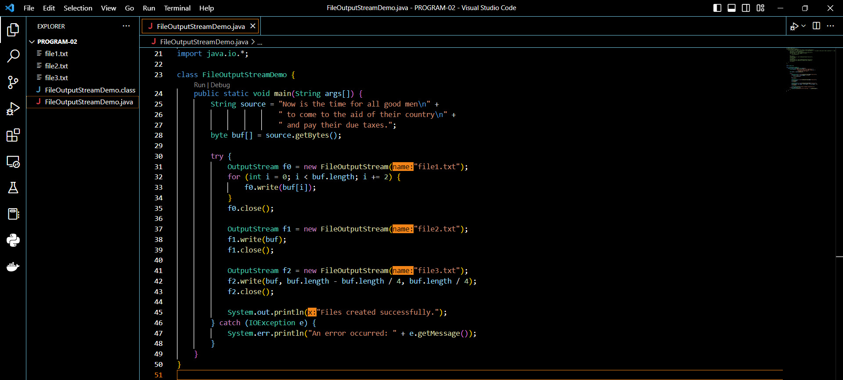

**Result-**

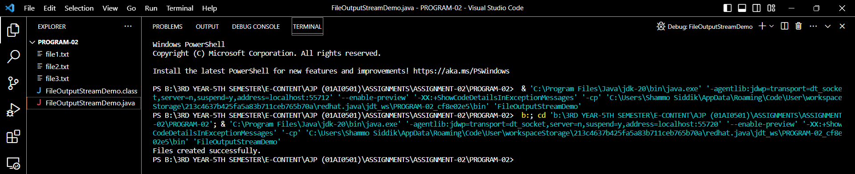

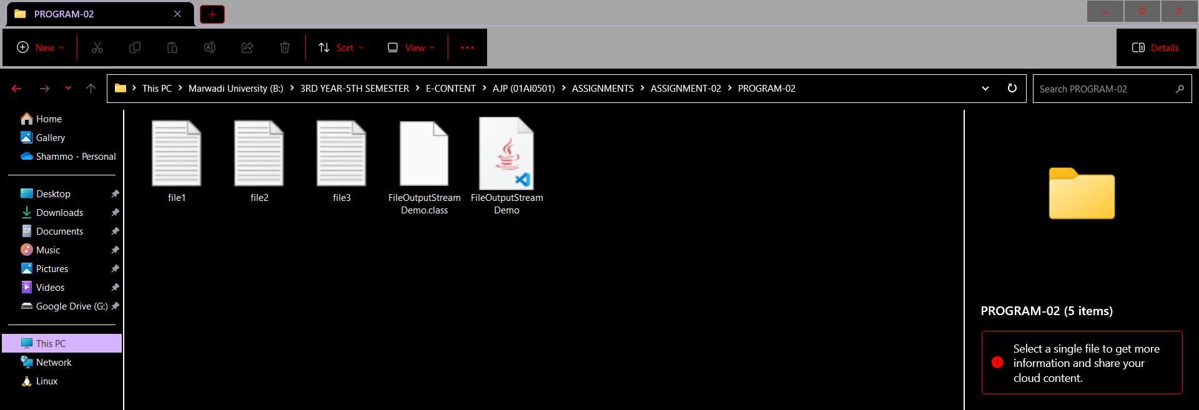

**PROGRAM-03:** The following example creates a pair of Byte Array Input Streams, initializing them with the byte representation of the alphabet.

**CODE:**

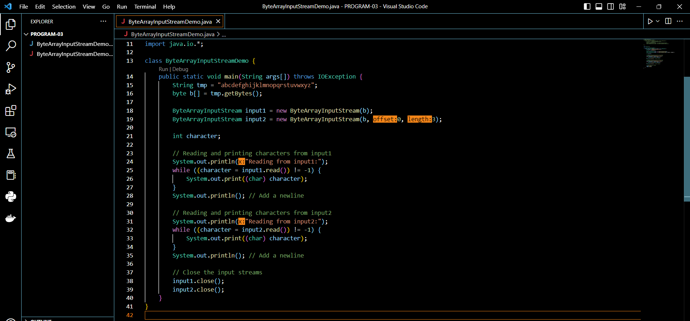

**Result-**

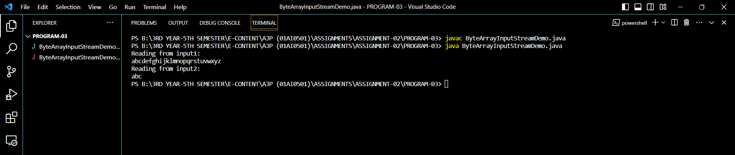

**PROGRAM-04:** The next example shows how to use the **reset( )** method to read the same input twice. In this case, we read and print the letters “abc” once in lowercase and then again in uppercase.

**CODE:**

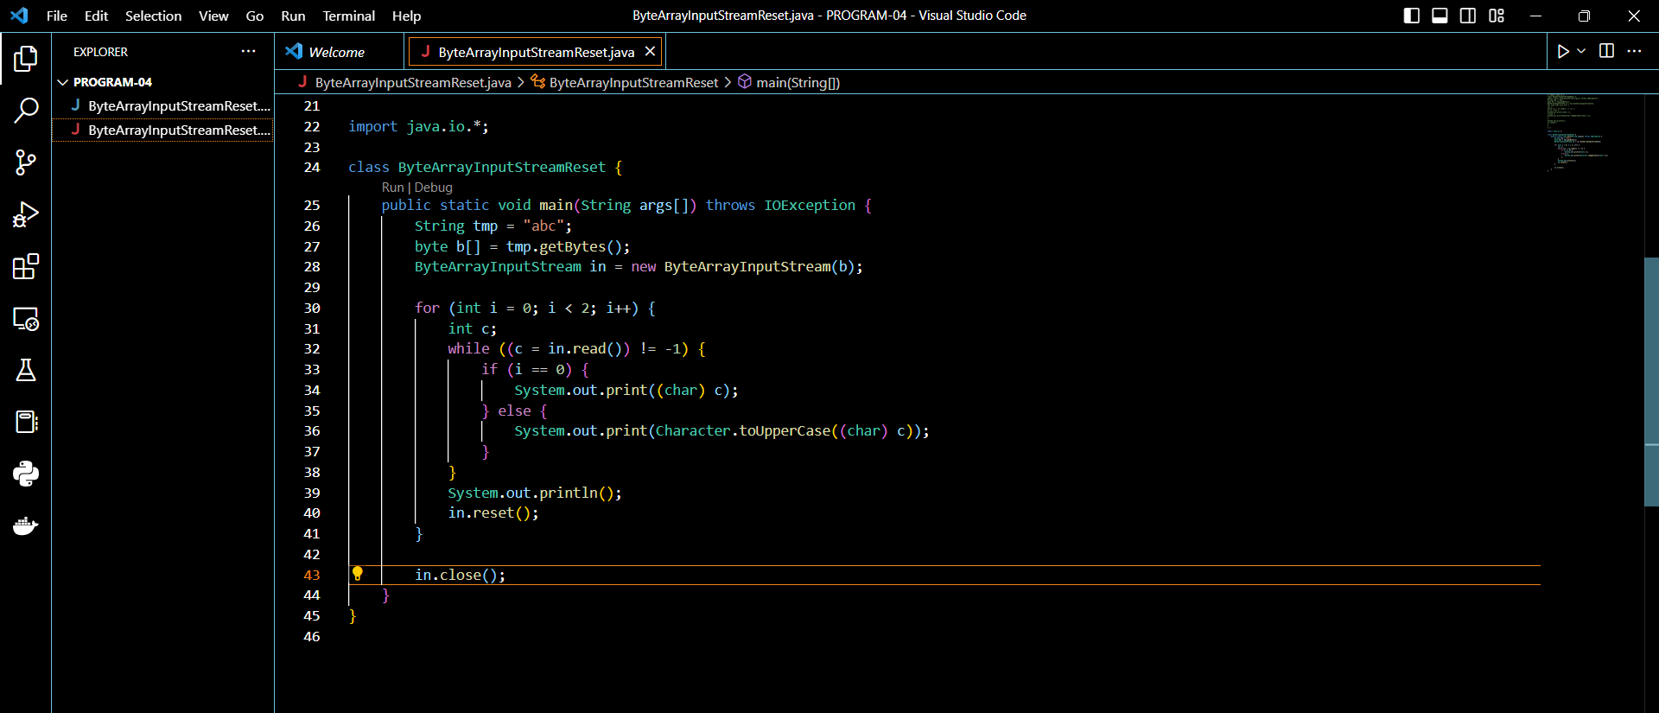

**Result-**

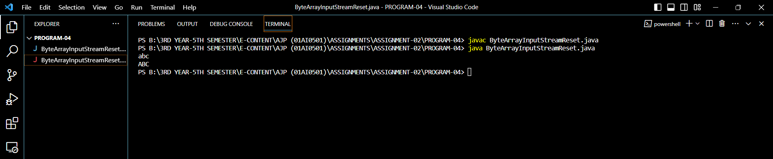

**PROGRAM-05:** Demonstrate the use of Byte Array Output Stream to write data and perform operations such as converting the buffer to a string, converting it to a byte array, writing it to another output stream, and resetting the buffer.

**CODE:**

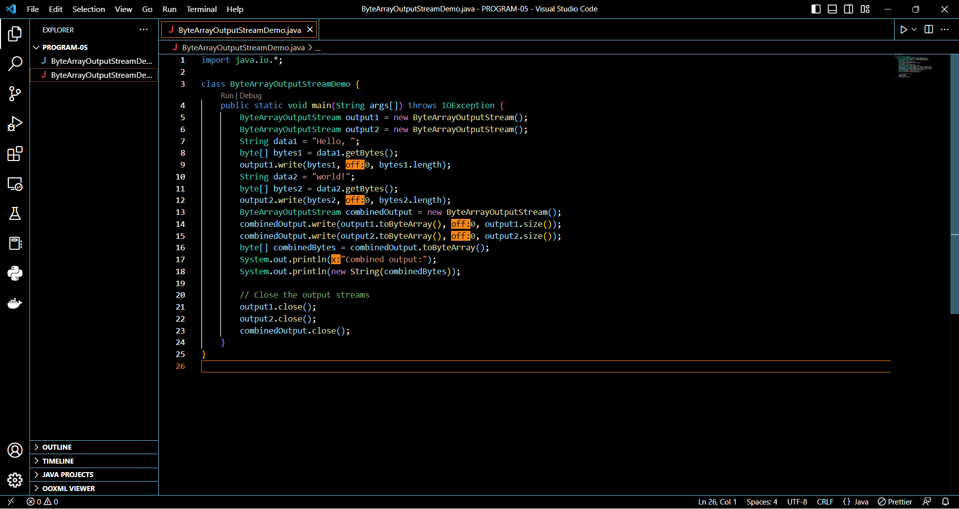

**Result-**

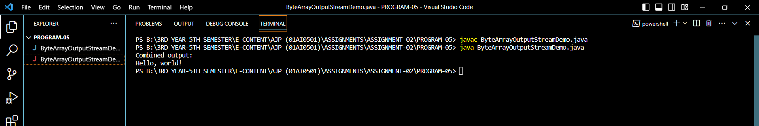

**PROGRAM-06:** Demonstrate the use of Byte Array Output Stream and its **reset()** method

**CODE:**

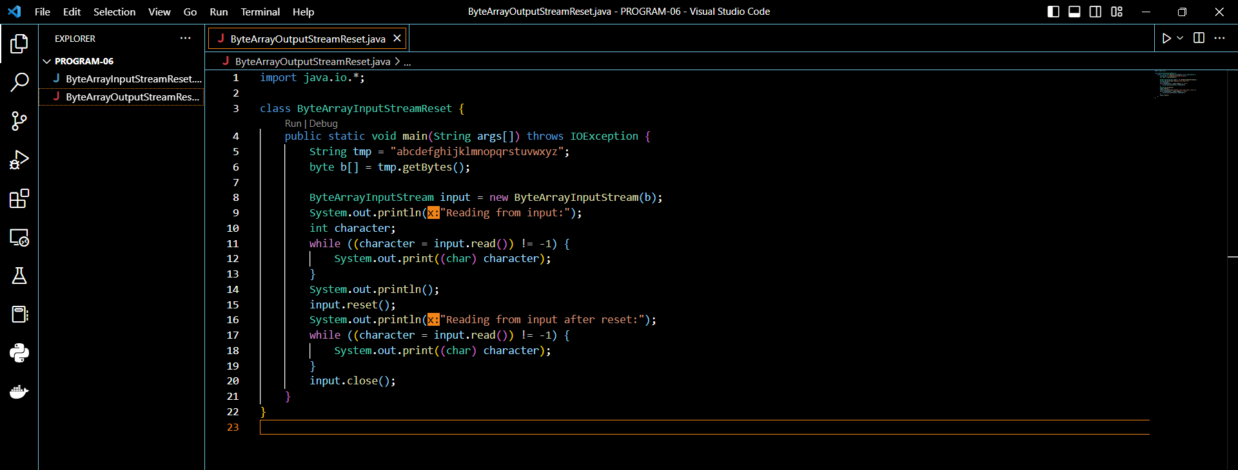

**Result-**

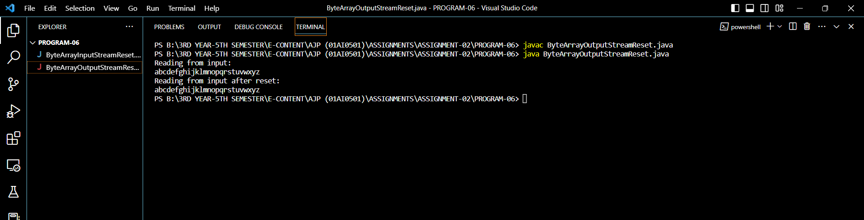

**PROGRAM-07:** Demonstrate the use of Buffered InputStream.

**CODE:**

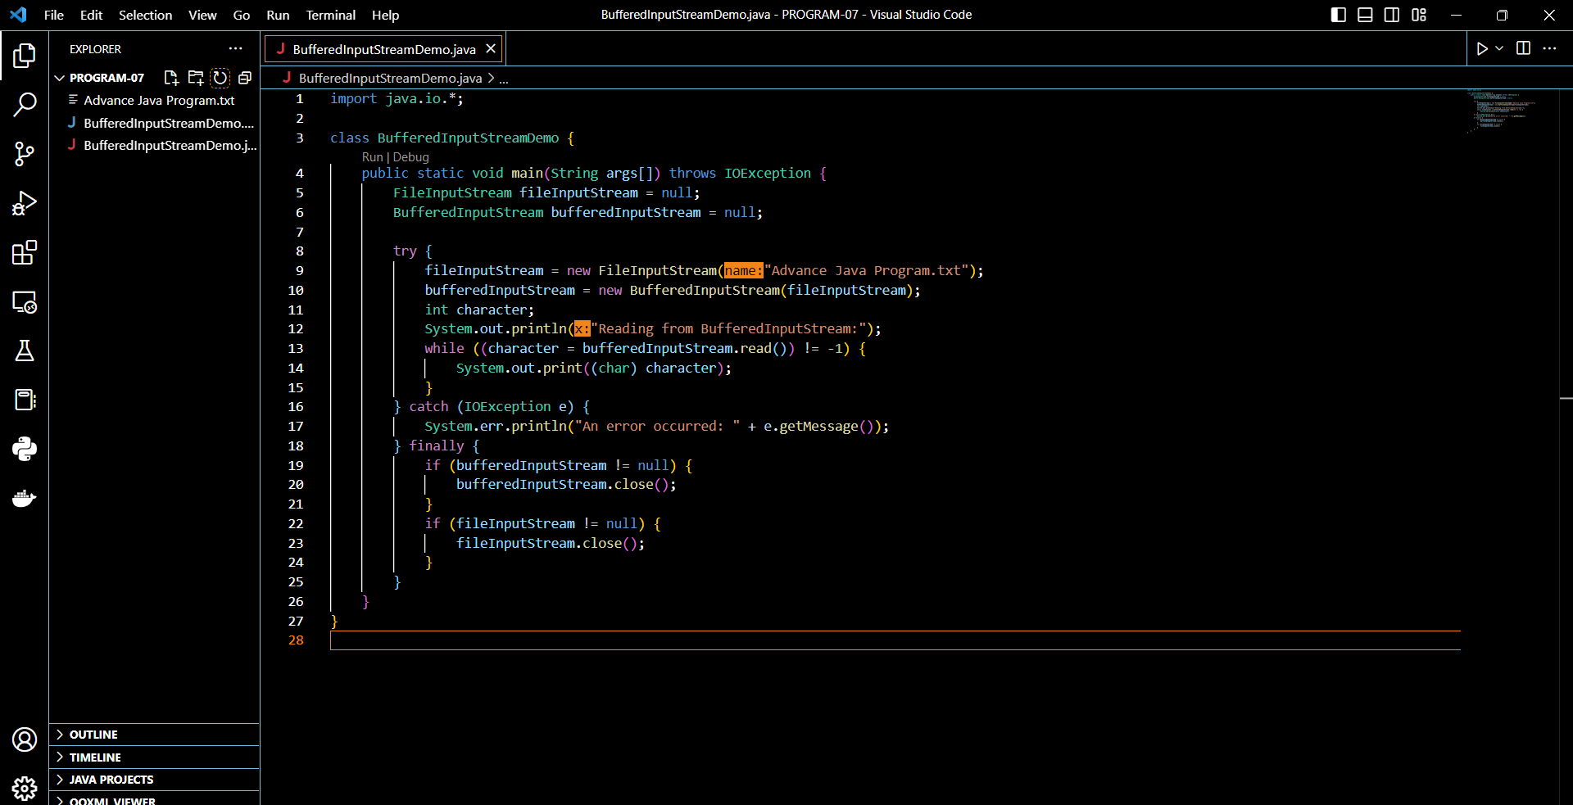

**Result-**

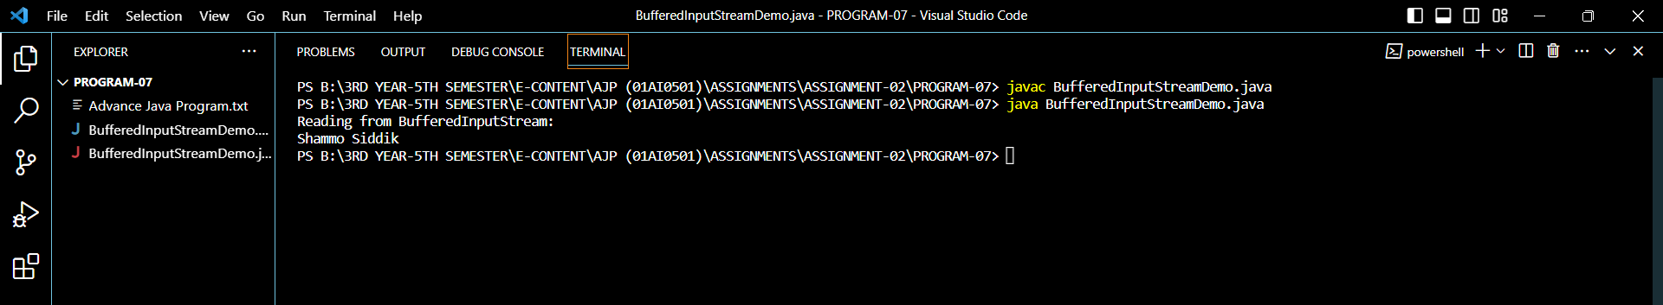

**PROGRAM-08:** The Buffered Input Stream Reset class demonstrates how to use a Buffered Input Stream to read data from a file ("sample.txt"). It first reads and prints characters from the buffered input stream. Then, it resets the buffered input stream using the **reset()** method, and reads and prints characters again after the reset.the for-each for loop to cycle through a Collection.

**CODE:**

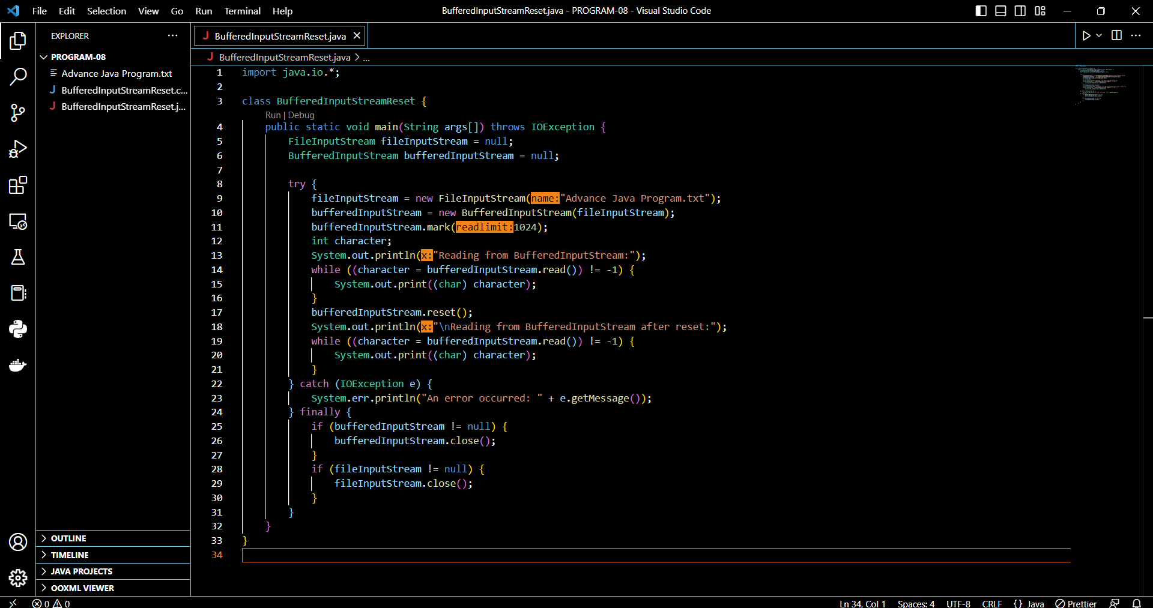

**Result-**

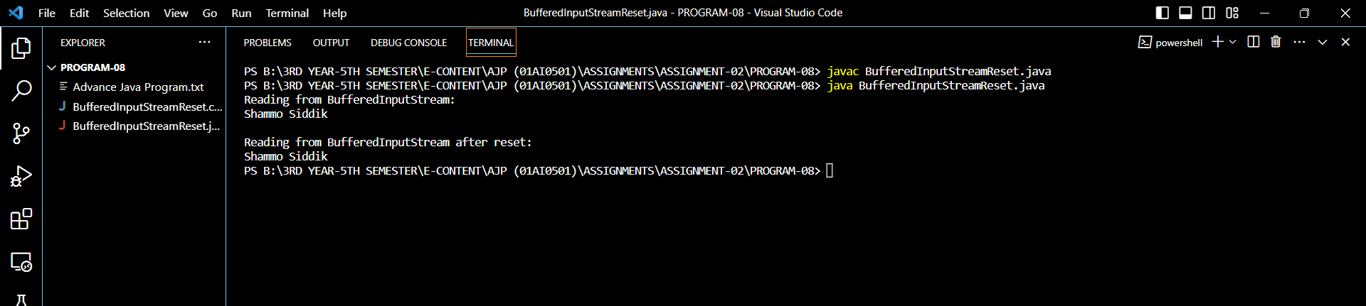

**PROGRAM-09:** In this program, the Buffered Output Stream Demo class demonstrates how to use a **B**uffered Output Stream to write data to a file ("output.txt"). The Buffered Output Stream is wrapped around a File Output Stream for improved performance. The data to be written is converted to bytes and written to the buffered output stream.

**CODE:**

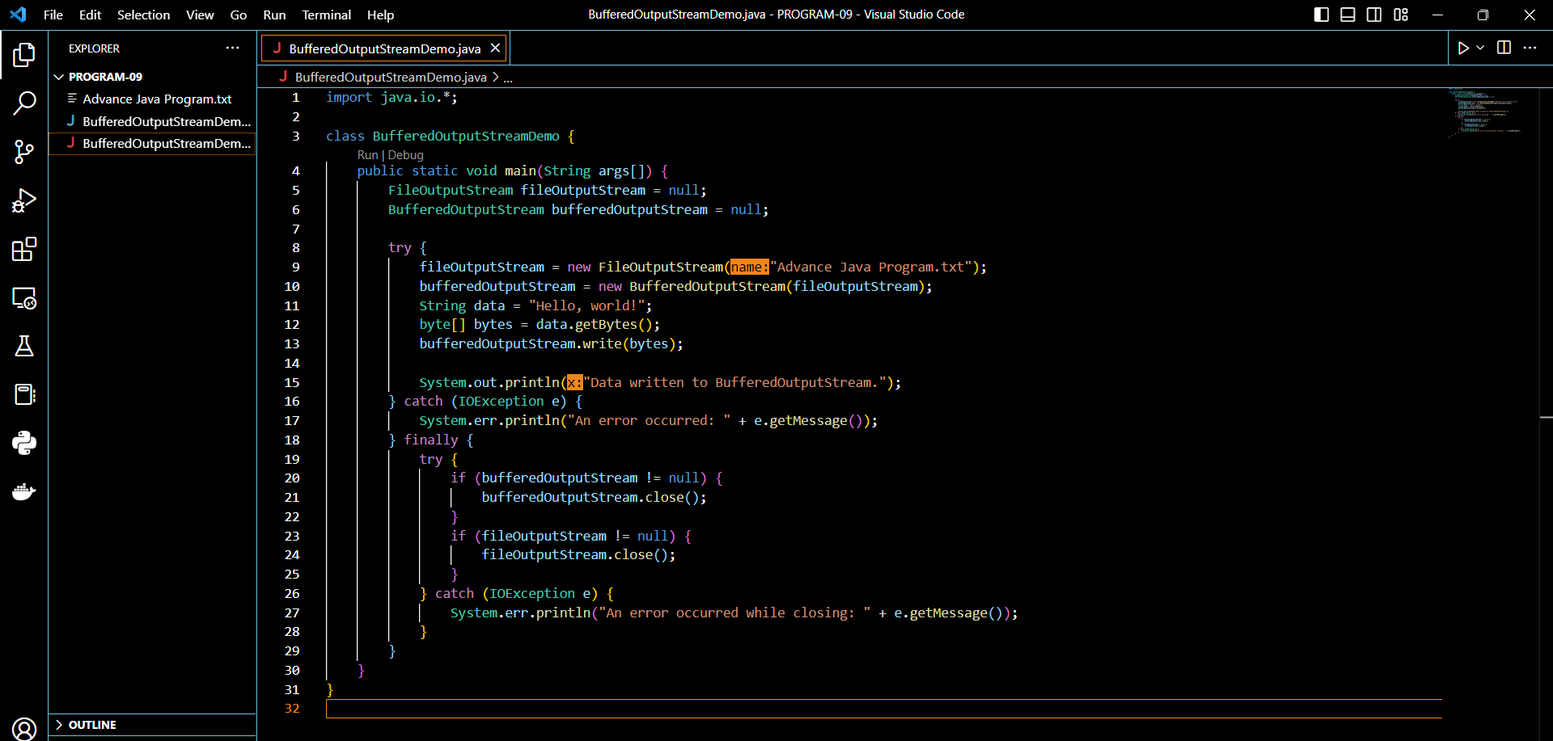

**Result-**

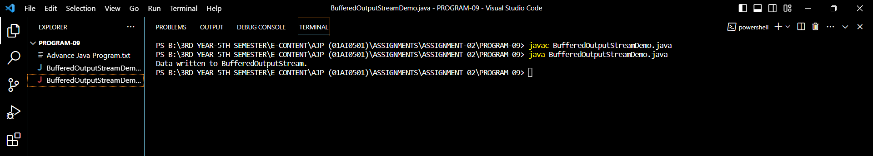

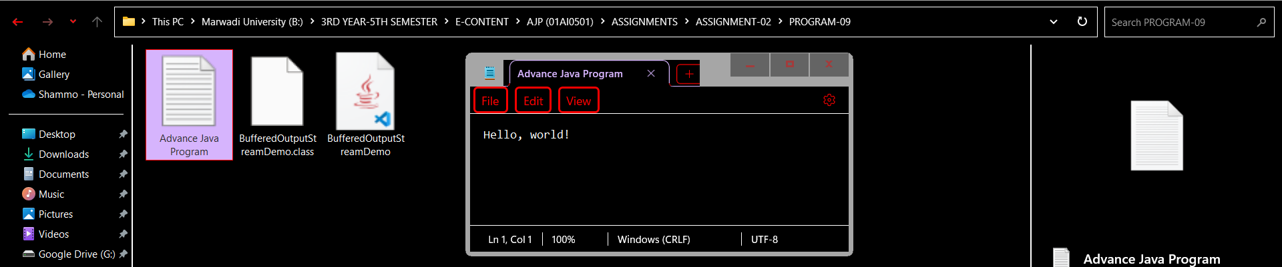

**PROGRAM-10:** In this program, the Buffered Output Stream Reset class demonstrates how to use a Buffered Output Stream to write data to a Byte Array Output Stream. It writes data to the buffered output stream, displays the written data, then resets the buffered output stream using the reset() method, and displays the state of the stream after the reset.

**CODE:**

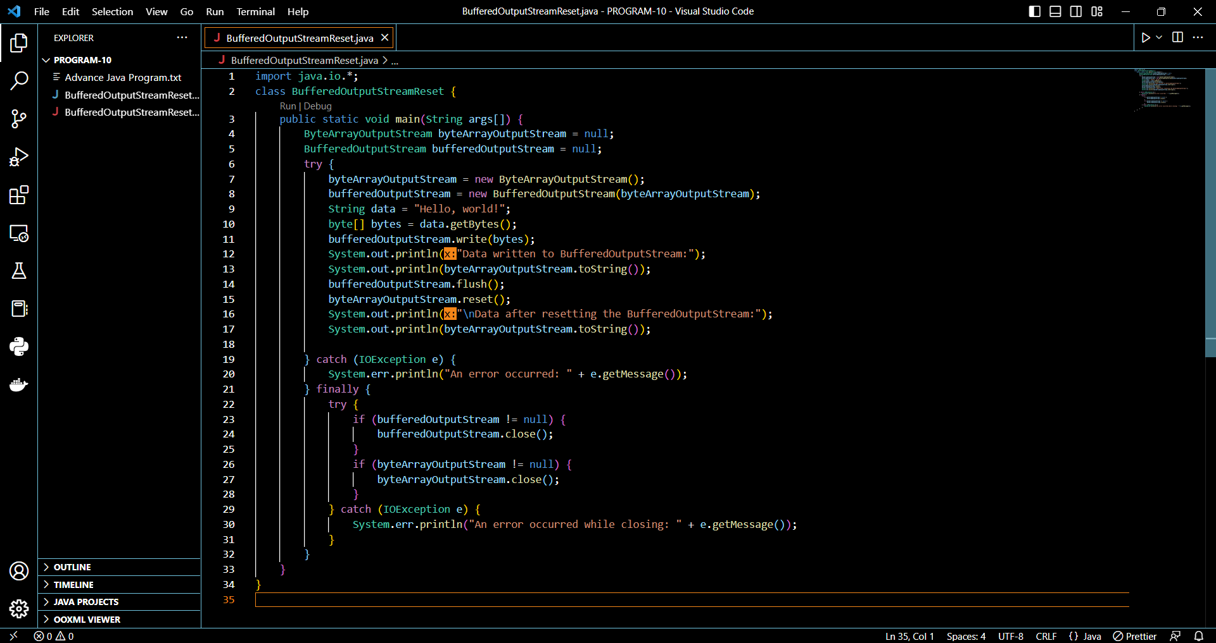

**Result-**

